Laura Schramm
Rote Song Treasure Hunt Lesson Plan - “The Golden Willow Tree”

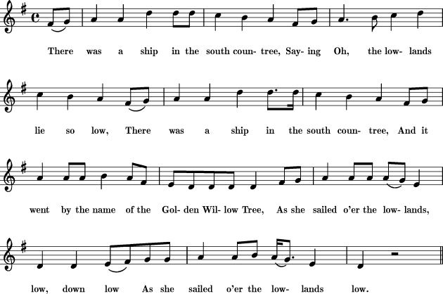
Taken from https://www.8notes.com/scores/6763.asp?ftype=gif with permission under Creative Commons Attribute 3.0.
More verses:
2. There was another ship in the same countree
Sailing o'er the lowlands lie so low
There was another ship in the same countree
And it went by the name of the Turkish Shagaree,
And she sailed o'er the lowlands, low down low,
As she sailed o'er the lowlands low.

3. Well, up speaks one little cabin-boy
Saying O, the lowlands lie so low
Oh, up speaks one little cabin-boy
Saying "What will you give me if that ship I'll destroy?
If I sink her in the lowlands, low down low,
If I sink her in the lowlands low."

4. "I'll give you gold and I'll give you fee,"
Saying O, the lowlands lie so low,
"I'll give you gold and I'll give you fee
And my oldest daughter your wedding-bride shall be,
If you sink her in the lowlands, low down low,
If you sink her in the lowlands low."
(http://kodaly.hnu.edu/song.cfm?id=716#analysis)

Form: AA’B
Mode: Mixolydian
This is an Anglo-American folk ballad (originally from Scotland or England) which has been passed on under a multitude of names of similar variant, including “Green Willow Tree”, “Merry Golden Tree”, “The Sweet Trinity”, “The Golden Vanity”, and many others. As much as the tune has changed titles, so has it changed melodically and in its lyrical content. The sea song details out the story of a ship in danger from another vessel, with the captain of the endangered ship sending out a “young cabin-boy” to put holes in the enemy ship to sink it. The boy engages the captain in a conversation about how the boy will be rewarded and eventually goes to do the job. Some versions have the boy swim back and be pulled to safety, others have him drown without ever having received his reward.
More information: http://www.loc.gov/folklife/LP/AngloAmericanBalladsAFSL7_opt.pdf

