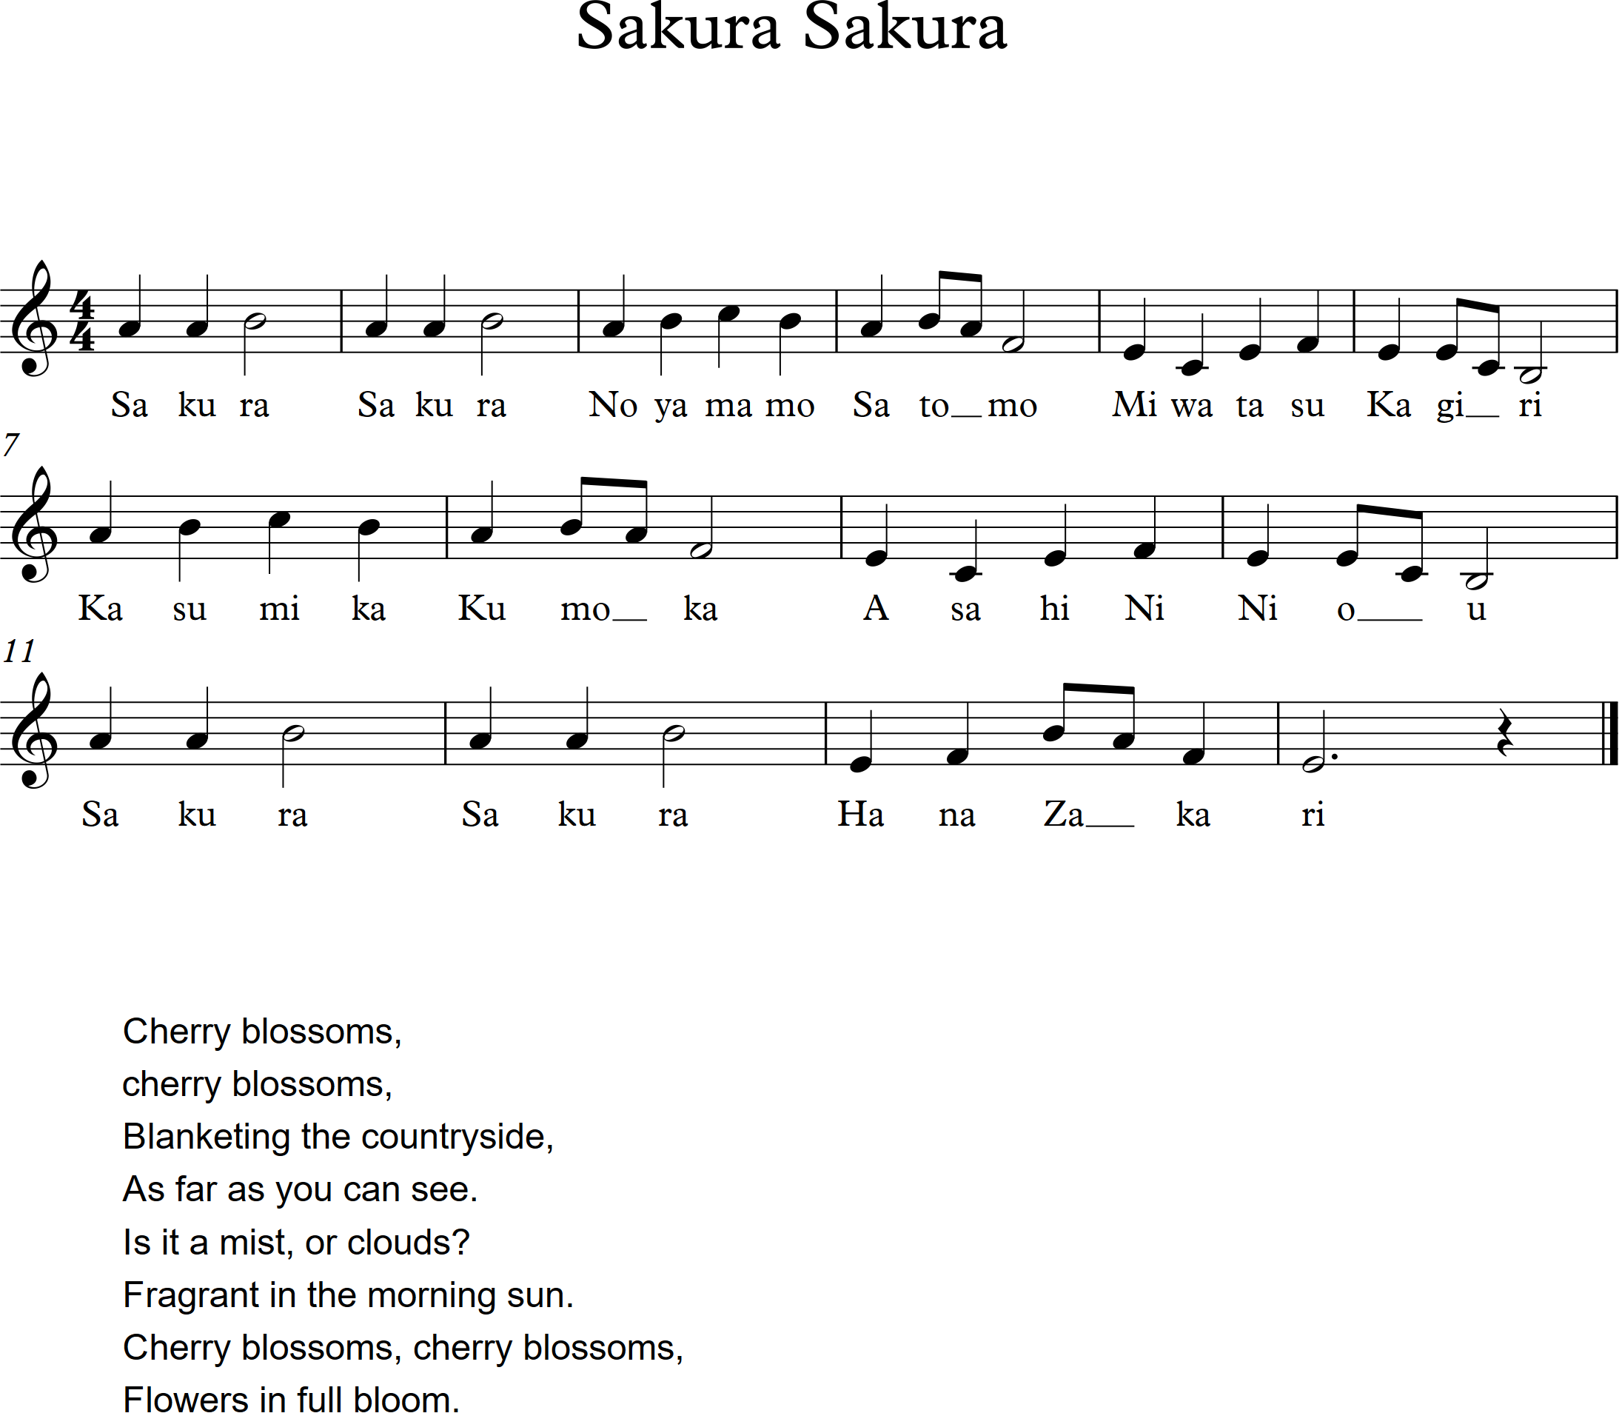

Sakura Sakura is a traditional Japanese folk song illustrating scenes of cherry blossoms in the springtime. The song originated in urban centers shortly before the beginning of Japan’s Meiji period, which started in the mid-1800s. Shortly thereafter, the Tokyo Academy of Music officially adopted Sakura as part of its regimen for students learning the koto, a 13-stringed traditional Japanese instrument. As the national flower of Japan, the cherry blossom holds great significance in Japanese culture, and is strongly represented in all art forms throughout the country. While Western ears will tend to associate the melody with the A natural minor pitch collection, the song is actually based on a pentatonic collection known as the “In” scale, which is one of two such collections that form the basis for most Japanese folk music.

