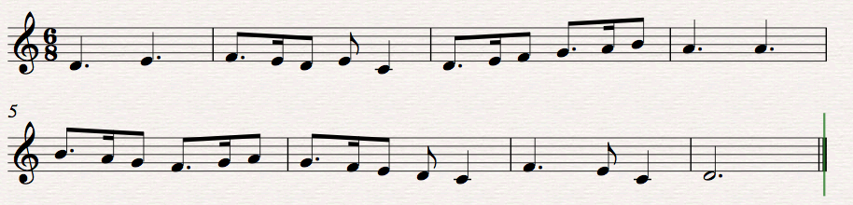
This song was composed by myself and is in the dorian mode. It was originally intended to be a song for an early childhood class or an elementary class song in order to introduce the dorian sound.

